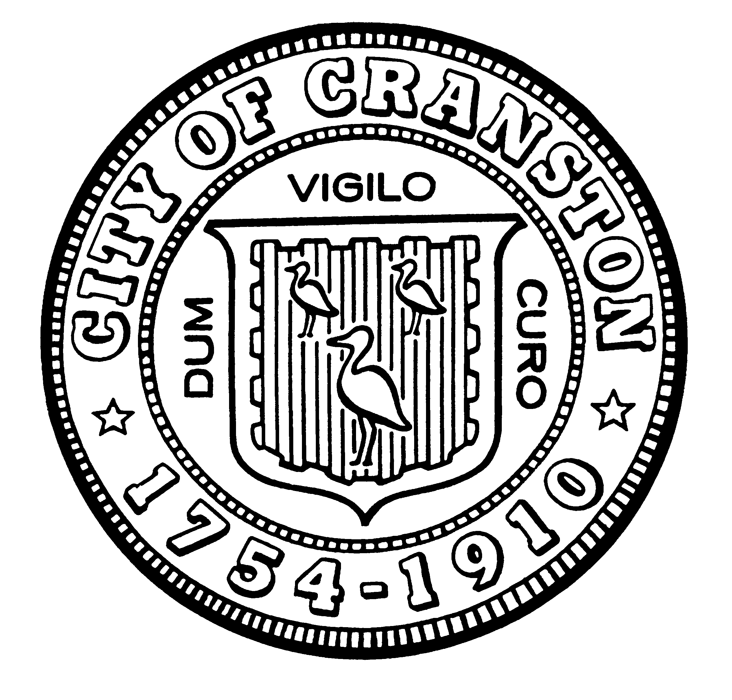

** CANCELLATION **

CRANSTON CITY COUNCIL
2023-2024 BUDGET HEARING NOTICE

Jessica M. Marino, Council President
Councilman John P. Donegan, Chair Finance Committee

.
** The budget hearings listed below, scheduled for April 27, 2023 and May 9, 2023
have been CANCELLED **

Thursday, April 27, 2023 @ 6:00 6:30 p.m.* Special City Council - Budget Hearing
Budget Adoption

Tuesday, May 9, 2023 @ 6:00 p.m. Special City Council

Consider possible Mayoral Vetoes; Final Adoption

Pursuant to R.I. Gen. Laws § 42-46-6(c) Notice of this meeting was posted on the Secretary of State’s website, on the city's website, at Cranston City Hall and at the Cranston Library on 3/29/2023 @ 9:40 a.m.

* Amendment posted 4/25/2023 to change the start time of this meeting from 6:00 p.m. to 6:30 p.m.
* Cancellation posted 4/26/2023

